**System Design Document**

**For**

**RF Direction Detection**

Cassandra Harrison

Robert Kramer

Sofia Mvokany

Krishna Patel

Kyle Reagan

|  |  |
| --- | --- |
| Version/Author | Date |
| 1.0/All | 9/29/2020 |
| 2.0/All | 10/29/2020 |
| 2.1/Krishna Patel | 11/17/2020 |
| 2.2/Krishna Patel | 11/19/2020 |
| 2.3/Krishna Patel | 11/20/2020 |
| 2.4/Cassandra Harrison | 11/29/2020 |
| 2.5/All | 11/30/2020 |

**1 INTRODUCTION**4

1.1 Purpose and Scope 4

1.2 Project Executive Summary 4

1.2.1 System Overview 4

1.2.2 Design Constraints 5

1.2.3 Future Contingencies 5

1.3 Document Organization 5

1.4 Project References 5

1.5 Glossary 6

**2 SYSTEM ARCHITECTURE**6

2.1 System Hardware Architecture 6

2.2 System Software Architecture 7

2.3 Internal Communications Architecture 7

**3 HUMAN-MACHINE INTERFACE**9

3.1 Inputs 9

3.1.1 Mission Planner 9

3.1.2 Arduino & Stepping Motor 9

3.2 Outputs 10

3.2.1 Mission Planner 10

3.2.2 Airspy 10

**4 DETAILED DESIGN**11

4.1 Hardware Detailed Design 11

4.1.1 Rotating Platform & Stepping Motor 11

4.1.2 Loop Antenna 14

4.2 Software Detailed Design 16

4.3 Internal Communications Detailed Design 16

**5 EXTERNAL INTERFACES**16

5.1 Interface Architecture 16

5.2 Interface Detailed Design 16

**6 SYSTEM INTEGRITY CONTROLS**16

# **1 INTRODUCTION**

## **1.1** **Purpose and Scope**

This document describes the system requirements, operating environment, system and subsystem architecture, files and database design, input formats, output layouts, human-machine interfaces, detailed design, processing logic, and external interfaces for the RF Direction of Arrival system. The scope of the project includes the receiving of 915MHz frequencies through a rotating loop antenna. The results will be displayed in real-time through a computer screen.

## **1.2** **Project Executive Summary**

### **1.2.1 System Overview**

There are three main sections to the system. One is the loop antenna, the RTL-SDR receivers, and the rotating platform. The loop antenna is a radio antenna consisting of a loop of copper wire and will be used as a receiving antenna at high frequencies. This loop antenna will be used for radio direction finding. RTL-SDR is software designed radio which is our computer-based radio scanner for receiving live radio signals within the area. The loop antenna will be connected to the rotating platform which will consist of the stepping motor. The stepping motor will rotate the loop antenna in the speed and direction we want. The motor is powered by the CNC shield and Arduino boards which get their instructions through the code written in Arduino. 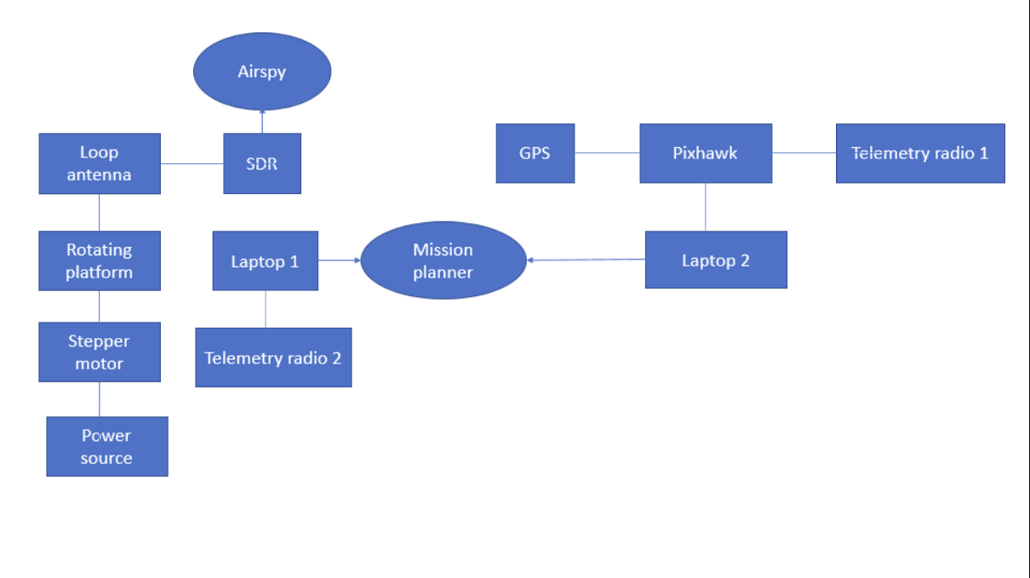

*Figure 1: High-level diagram of the system*

### **1.2.2 Design Constraints**

The two design constraints are the Pixhawk simulation drone that all testing will be done on as we do not have access to a drone to test it out in real-time and the budget constraint we had to keep all equipment ordered for the design under $1500.

### **1.2.3 Future Contingencies**

There will be no contingencies applied to this system in the future. In the future, a MATLAB integrated into the system will replace Airspy. Since this system is completely modular it will be able to adapt to system design changes. Airspy is used to display the signals received, the MATLAB integration will include more user input to make it more immersive.

## **1.3** **Document Organization**

This System Design Document details the system architecture in a high-level manner. It will briefly discuss the hardware and software system architecture. Along with the Human-Machine Interface where the inputs and outputs will be discussed. After that, there will be a detailed design section where it goes further into the hardware and software design aspects of the system. It will conclude with a short section discussing the integrity controls of the system.

## **1.4** **Project References**

The key references used in the creation and formation of the subsystem:

1. ARDUINO CNC SHIELD CONTROL STEPPER. [Online]. Available: <http://aconcaguasci.blogspot.com/2016/11/arduino-cnc-shield-control-stepper.html>. [Accessed: 21-Sept-2020 through 24-Nov-2020].
2. CNC ARDUINO SHIELD. [Online]. Available: <https://courses.ideate.cmu.edu/16-375/f2017/text/resrc/cnc-shield.html#nema17-stepper-motor>. [Accessed: 28-Oct-2020 through 24-Nov-2020].
3. LECTURE 11: LOOP ANTENNAS. [PDF]. Available: <http://www2.elo.utfsm.cl/~elo352/biblio/antenas/Lectura%2011.pdf>. [Accessed: 11-Sept-2020 through 24-Nov-2020].
4. HANDHELD DIRECTION-FINDING LOOP ANTENNA FOR RFI LOCATION. [PDF]. Available: <http://www2.elo.utfsm.cl/~elo352/biblio/antenas/Lectura%2011.pdf>. [Accessed: 11-Sept-2020 through 24-Nov-2020].

## **1.5** **Glossary**

CNC - Computerized Numerical Control

DOA- Direction of Arrival

MAV- [MicroAerialVehicle](https://en.wikipedia.org/wiki/Micro_air_vehicle)

RF- Radio Frequency

RTL- RealTek

SDD - Software Design Document

SDR - Software Defined Radio

WP - Waypoint

# **2** **SYSTEM ARCHITECTURE**

## **2.1** **System Hardware Architecture**

The system hardware architecture is described in Figure 1 previously mentioned in the System Overview section of the SDD. This section will go in-depth about what each subsystem will do.

* Motor: The stepping motor is wired to a CNC shield and connected to an Arduino Uno board.
* Rotating platform: The rod attached to the stepping motor, where the loop antenna will attach to.
* Loop Antenna: A coiled copper wire, the purpose will be to receive radio frequencies.
* Software Defined Radio: Helps detect the radio frequencies within the area and make it visible on the computer.

## **2.2** **System Software Architecture**

**2.2.1 Rotating Platform** 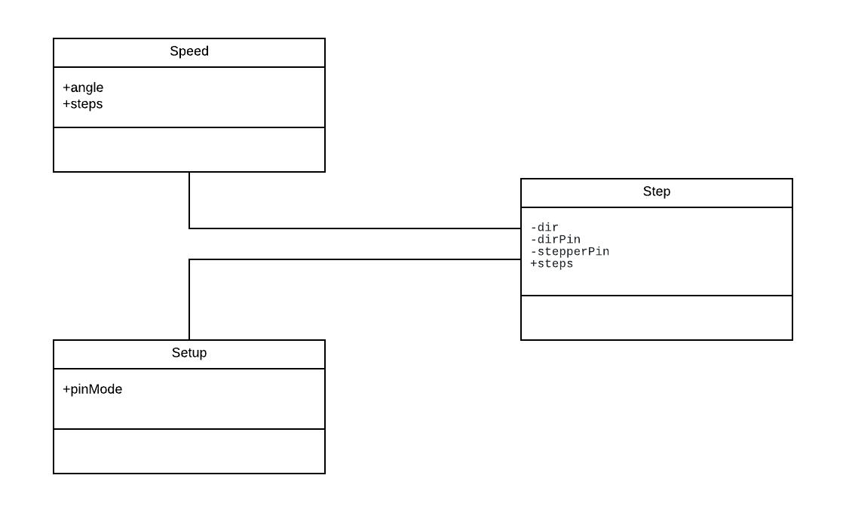

*Figure 2: Class diagram of the rotating platform*

The rotating platform allows the loop antenna attached to it to rotate at the speed and directions set by the user. The simple code to run the stepper motor is explained in the diagram below. Note that this is not a traditional class diagram as used in software development, since the code is so simple.

Speed: Controls the speed of the rod attached to the stepping motor and returns the angle at which it is currently at.

Setup: Assigns the X, Y, Z directions to the corresponding pins on the CNC and Arduino Uno boards.

Step: The main function that outputs the angle on the serial port and transmits the speed and direction to the stepping motor.

## **2.3** **Internal Communications Architecture**

The data flow diagram below represents the internal communications of the system. The loop antenna attached to the rotating platform will turn in the speed and direction coded in by the user. As the loop antenna rotates, the RTL-SDR will assist the loop antenna scan for frequencies around 915Mhz which the user will be able to see through their PC. Once the frequency has been caught the rotating platform will stop rotating so we can continue reading the signal that was scanned.

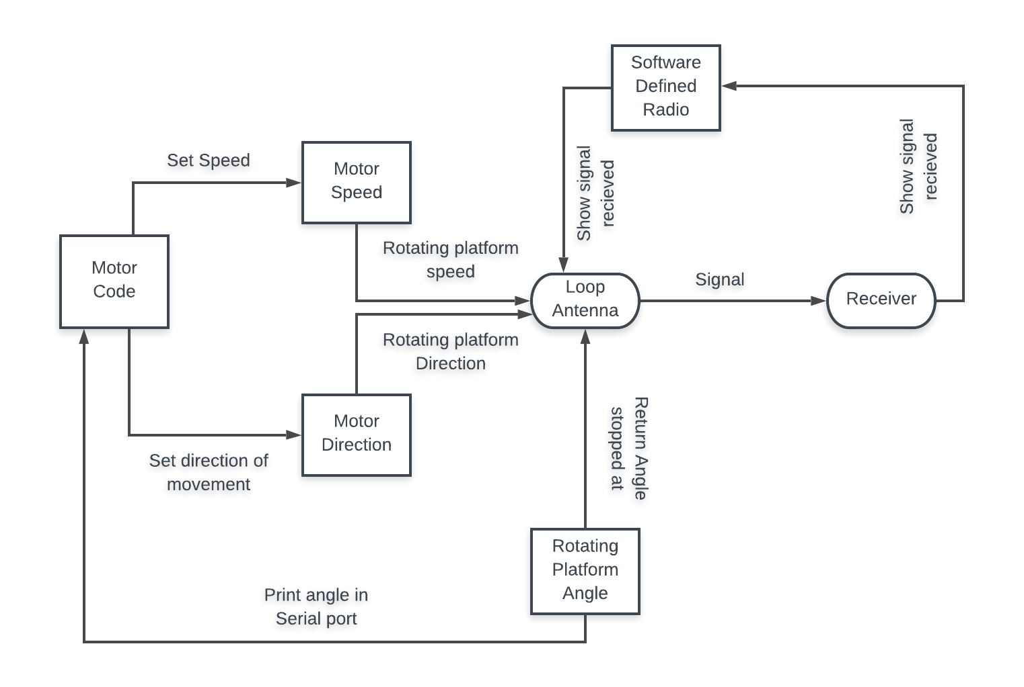*Figure 3: Data flow diagram of the process of RF direction detection*

# **3** **HUMAN-MACHINE INTERFACE**

This section provides details of the inputs and outputs to verify the system’s ability to accurately detect 915MHz frequencies in the nearby area, within a controlled simulation of the drone.

## **3.1** **Inputs**

### **3.1.1 Mission Planner**

To perform the simulation of the drone the operator will have to use a Pixhawk for the Mission Planner software to be able to display a drone simulation. To do this, the Pixhawk device is attached to a telemetry radio and connected to the computer running Mission Planner. Once in Mission Planner, in the upper right-hand corner of the interface allows for customization of the type of connected device before connection. Once ready to connect, simply select the connect button. 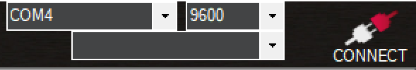

*Figure 4: Customization of the type of connected device before connection*

Once the interface is connected, the connectivity part of the interface will appear as the figure below.

*Figure 5: Customization of the type of connected device after connection*

### **3.1.2** **Arduino & Stepping Motor**

To turn the system on, plug in the Arduino board that is connected to the stepping motor and the 12-volt battery supply, to the Laptop, and upload the preexisting code. This will start the stepping motor and begin to rotate the loop antenna that is connected to the rotating platform.

## **3.2** **Outputs**

### **3.2.1 Mission Planner**

When running a Mission Planner, the user will be presented with a simulation window. This simulation will display a simulation of the virtual done including flight parameters and projected flight path. The flight parameters given include altitude, ground speed, distance to WP, yaw, vertical speed, and the distance to MAV on the first tab of parameters. Additional information about the flight and flight path can be found both on the additional tabs in the bottom right part of the interface, and within the simulated flight view in the top right part of the interface. The user with the second Pixhawk setup can see the changes in the drone’s screen in real time. 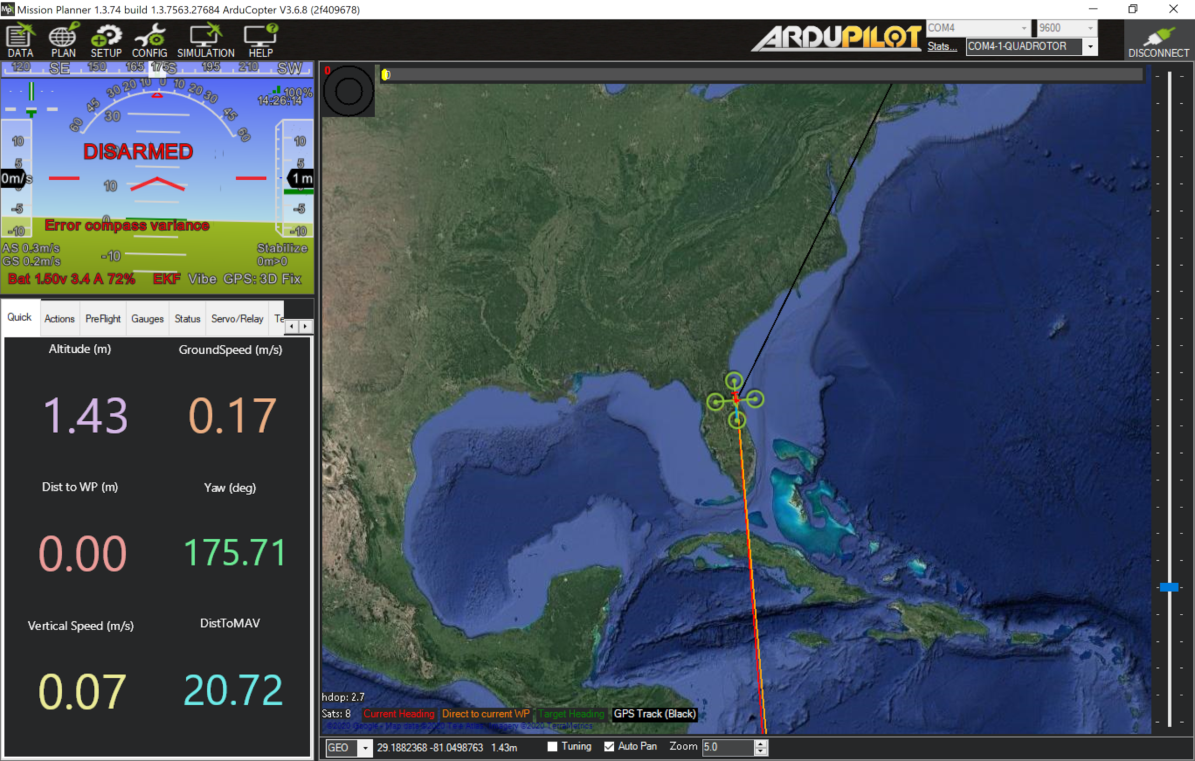

*Figure 6: Mission Planner/Pixhawk simulation display*

### **3.2.2 Airspy**

When running Airspy, the user will be presented with the radio frequencies that the loop antenna can catch. This will display the dB loss of the data exchanged between the telemetry radio hooked to the Pixhawk and the one hooked to the laptop. The user will be able to see the frequency range, bandwidth, and listen to the audio when applicable. The interface of Airspy lets the user offset the frequency, isolate the bandwidth, and also filter the sound like in the case of FM radios.

# 

*Figure 7: Airspy radio frequency display*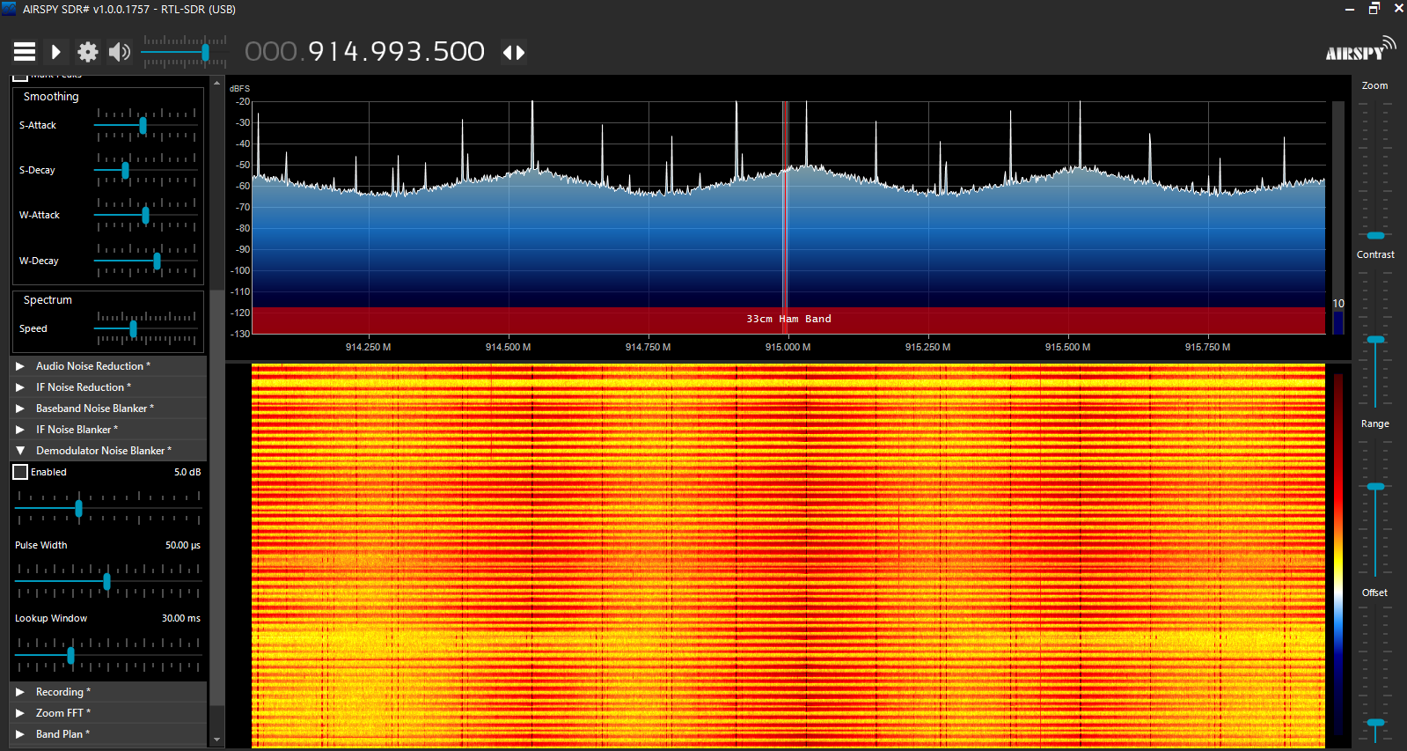

# **4** **DETAILED DESIGN**

## **4.1** **Hardware Detailed Design**

This section aims to depict the RF Direction Detection physical system functionality through detailed design models of the rotating platform/stepping motor, loop antenna, and the SDR. This will clarify the connections between all three systems.

### **4.1.1** **Rotating Platform & Stepping Motor**

The stepping motor consists of the CNC shield attached to the Arduino Uno. The motor is wired to the CNC shield and with a 12-volt battery supply. Attached to the rod of the motor is the rotating platform. The rotating platform is 3D modeled and printed. The following figures describe the schematics, wiring, and dimensions of the stepping motor and rotating platform.

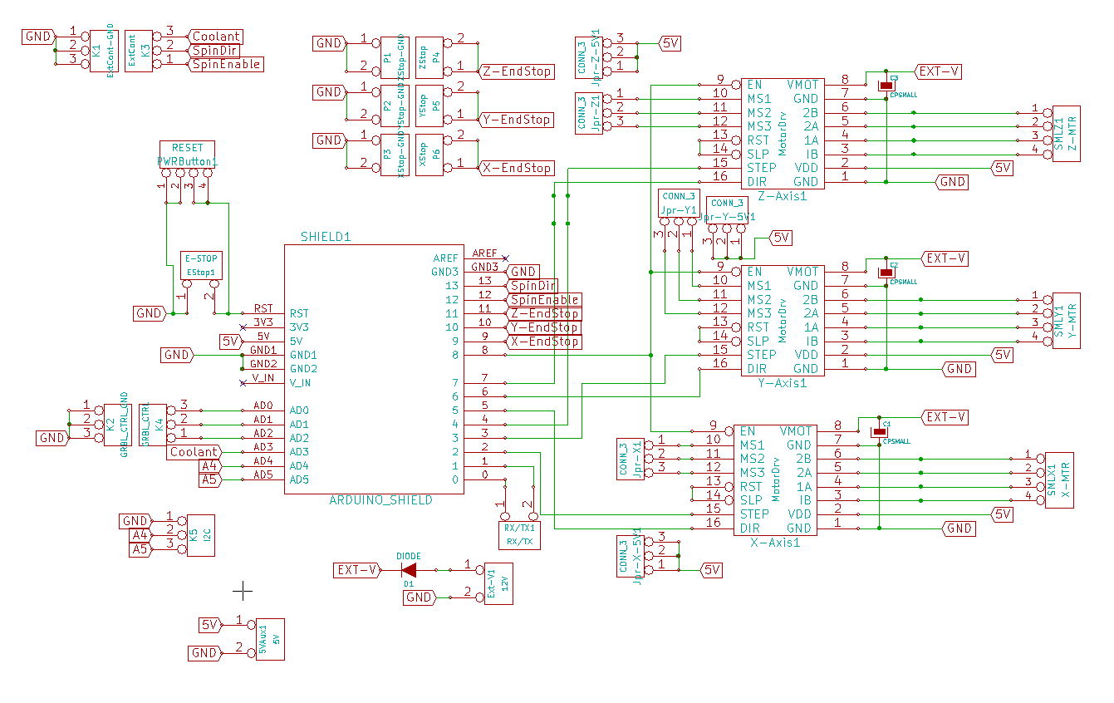

*Figure 8: Pin mapping and wiring of the CNC shield* 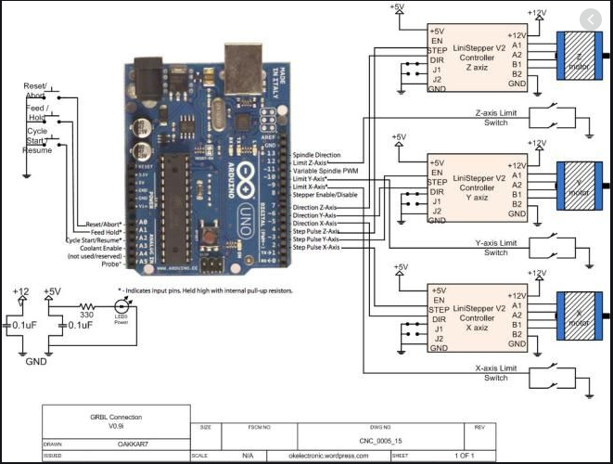

*Figure 9: Pin mapping and wiring of the Rotating Platform on Arduino Uno Board*

*Figure 10: Datasheet of the Nema 17 Stepper Motor connected to the CNC shield*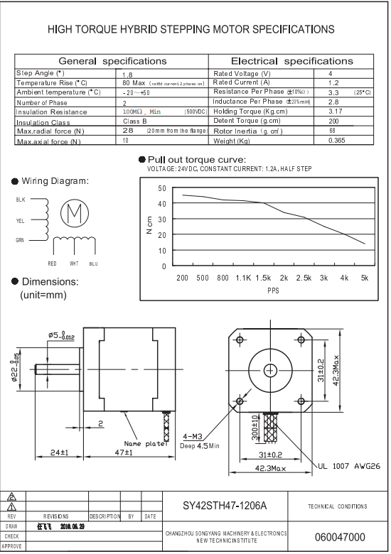

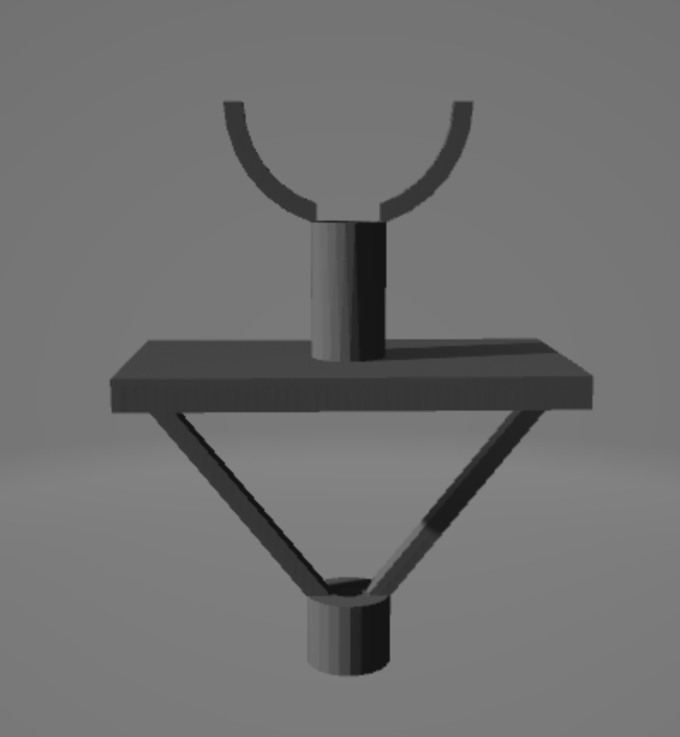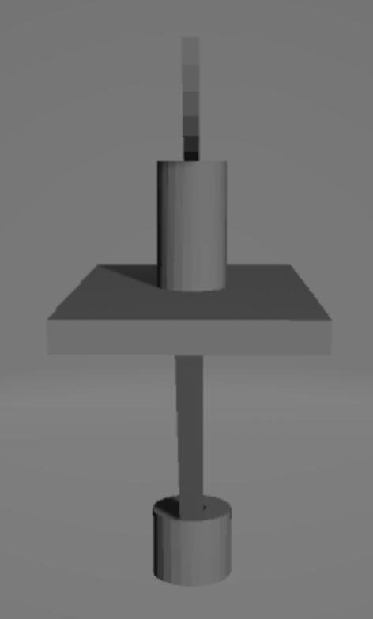

*Figure 11: AutoCAD drawing of the rotating platform*

### **4.1.2** **Loop Antenna**

The loop antenna will be approximately 32.7 mm in diameter, 10% of the target wavelength. At 915 MHz, the wavelength is about 32.7 cm. To make a magnetic/electrically small loop antenna, the largest linear dimension (diameter) must be 1/10 of the wavelength. The antenna must be made out of a conductive material, in this case, copper. The loop is created and then soldered onto the end of a copper wire with a male SMA connector at the opposite end to connect to the SDR. When the incoming signal is perpendicular to the plane of the loop, the received signal gain will display a sharp drop

**4.1.3 RTL-SDR**

The RTL-SDR is a USB dongle that works with the Airspy software. It is composed of one USB port to connect it to the laptop and one female SMA connector to connect an antenna.

*Figure 12: RTL-SDR (silver) USB dongle connected to laptop*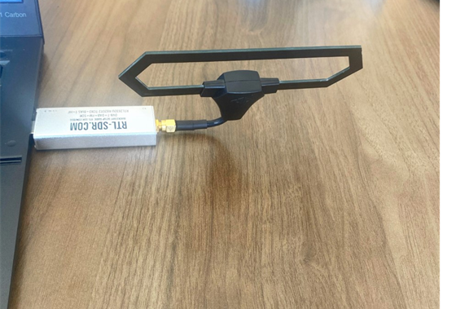

**4.1.4 GPS**

The PixHawk GPS module is connected to the Pixhawk by a 4-wire cable.

*Figure 13: PixHawk GPS* 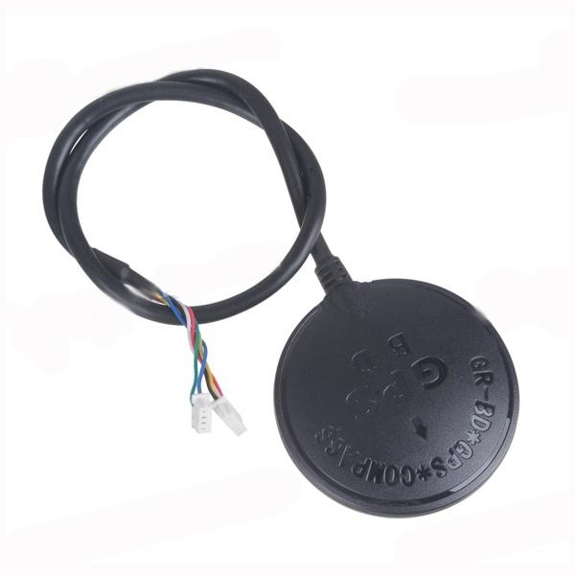

## **4.2** **Software Detailed Design**

This section is not applicable as there is no major software component of the system. The Rotating platform basic software to control speed and directions and printing the angle of the loop has been described in the System Software Architecture section of the SDD. In the future, we may add a MATLAB component to this design and will update this section at that time.

## **4.3** **Internal Communications Detailed Design**

The antenna will produce a voltage signal based on the direction and frequency of the observed signal which the SDR will compute and visually display.

# **5** **EXTERNAL INTERFACES**

The other system that works alongside the RF Directions Detection system will be any drone within the area. There is no system that needs to work simultaneously with the RF Direction Detection system. The RF Direction Detection system is scanning for drones within the area if it does not find one then there are no drones in the area.

## **5.1** **Interface Architecture**

The communication between the drone in question is described in the Human-Machine Interfaces Input section of the SDD. The frequency the drone runs on will be scanned by the loop antenna and the software-defined radio. Once detected by the system the Rotating Platform will stop so the loop antenna and software design radio can continue receiving the signal of the drone and display

## **5.2** **Interface Detailed Design**

See diagrams in Human-Machine Interfaces Input and Output.

# **6** **SYSTEM INTEGRITY CONTROLS**

There is no sensitive information to the software or hardware of the system. The system is created for an IEEE competition and will be available to students of the Embry Riddle Campus to demonstrate RF Direction Detection. The general public will be provided with the information and design of the system.